Ask a scientist worksheet

4.2 Scientists understanding of matter has developed over the years

Pages 64–65

Ms Jenny Powell – environmental scientist

Read the Ask a Scientist box on the next page before completing these questions.

1 Draw a timeline below of Jenny’s career in science from her early interests to her current PhD.

2 What sort of activities does Jenny complete throughout her workday?

3 In your own words, why is the study of air quality in the home important for the health of individuals?

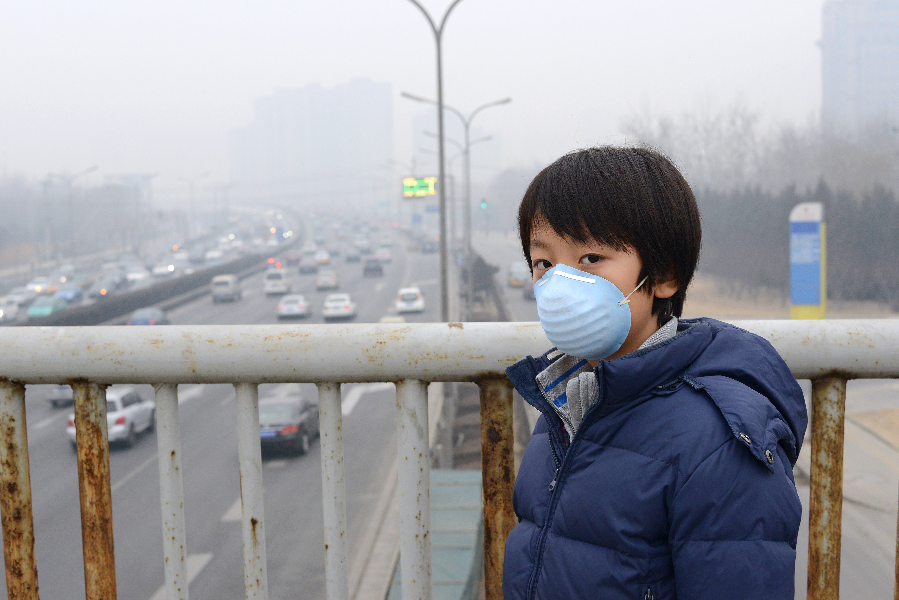

4 Beijing, the capital of China, has been suffering severe air pollution for many years now. What do you think could be contributing to the air quality issues in Beijing?

_______________________________________

_______________________________________

_______________________________________

_______________________________________

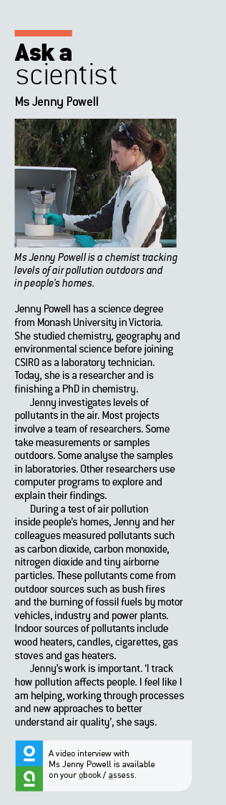5 How do you think Beijing could improve its air quality?

_________________________________________________________

_________________________________________________________

_________________________________________________________